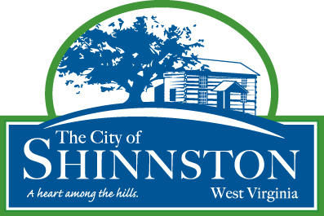

SHINNSTON CITY COUNCIL MEETING
SHINNSTON CITY COUNCIL CHAMBERS
WOMANS CLUB 28 Bridge Street, Shinnston, WV
TIME: October 13, 2026, 07:00 PM

CALL TO ORDER AND WELCOME: Mayor Patrick Kovalck

PLEDGE AND INVOCATION

PETITION OF THE CITIZENS

APPROVAL OF MEETING MINUTES: Public Hearing September 14, 2026, Regular Meeting September 14, 2026 AND Work Session September 28, 2026

EXECUTIVE REPORTS and UPDATES: Mayor Patrick Kovalck, City Manager Tori Drainer

PROJECT UPDATES

OLD BUSINESS:

NEW BUSINESS:

- Introduction, first reading, set Public Hearing for An Ordinance Of The City Of Shinnston To Amend And Restate Article 753.02 Of The Codified Ordinances Of The City Of Shinnston, To Increase/Clarify The Police, Street And Fire Service Fees.
- Review, discuss, consider Halloween 2026’s date and time for trick or treating.
- Review, discuss, consider the General Collection Services Agreement for delinquent citations.
- Review and discuss Power Plant water supply update.

ADJOURNMENT:

