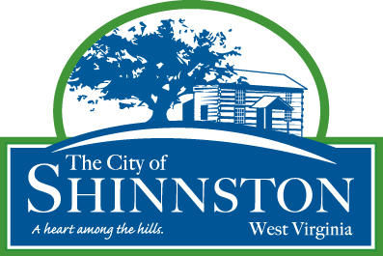

SHINNSTON CITY COUNCIL MEETING
SHINNSTON CITY COUNCIL CHAMBERS
43 BRIDGE STREET
TIME: September 14, 2026, 07:00 PM

CALL TO ORDER AND WELCOME: Mayor Patrick Kovalck

PLEDGE AND INVOCATION

PUBLIC HEARING AN ORDINANCE IMPLEMENTING THE CITY’S MUNICIPAL HOME RULE AUTHORITY TO AUTHORIZE INTERGOVERNMENTAL AGREEMENTS BY RESOLUTION.
PUBLIC HEARING FOR CITY OF SHINNSTON’S SOURCE WATER PROTECTION PLAN.

PETITION OF THE CITIZENS

APPROVAL OF MEETING MINUTES: Regular Council Meeting August 10, 2026, and Special Meeting and Work Session August 31, 2026

EXECUTIVE REPORTS and UPDATES: Mayor Patrick Kovalck, City Manager Tori Drainer

OLD BUSINESS:
1 - Second Reading and Adoption An Ordinance Implementing the City’s Municipal Home Rule Authority to Authorize Intergovernmental Agreements by Resolution.
2 - Review, discuss, consider the Change Order for Phase 3 Water Project with Stantec.

NEW BUSINESS:
1 – Review, discuss, consider the longevity of the fencing of the rail trail and requesting quotes for new fencing.
2 – Review, discuss, consider raising the police fee.
3 - Review, discuss, consider corrective deed from LR Builds, or its affiliates, to the City of Shinnston, WV related to the Harrison County/Shinnston Rail Trail Corridor (potential executive session to discuss matters involving commercial competition or to discuss matters pursuant to the attorney-client privilege).
4 – Review, discuss, consider the completion of mold remediation of 43 Bridge Street by Rapid Disaster Solutions.

ADJOURNMENT:

